

**Module Title : COMPUTER SYSTEMS**

**Assignment Title : PRACTICAL PORTFOLIO**

**Examination Cycle : Summer 2024**

**Candidate Name : YAN LINN AUNG**

**Candidate No : P00200770**

**Centre Name : KMD COMPUTER CENTRE (YANGON)**

**Submission Date :**

**Important Notes:**

* Please refer to the Assignment Presentation Requirements for advice on how to set out your assignment. These can be found on the NCC Education *Campus*. Scroll down the left hand side of the screen until you reach Personal Support. Click on this, and then on Policies and Advice. You will find the Assignment Presentation Requirements under the Advice section.
* You must familiarise yourself with the NCC Education Academic Dishonesty and Plagiarism Policy and ensure that you acknowledge all the sources which you use in your work. The policy is available on *Campus*. Follow the instructions above, but click on Policies rather than Advice.
* You must complete the **‘Statement and Confirmation of Own Work’**. The form is available on the Policies section of *Campus*. Scroll down the left hand side until you reach Personal Support. Click on this and then click on Policies and Advice.
* Please make a note of the recommended word count. You could lose marks if you write 10%more or less than this.
* You must submit a paper copy and digital copy (on disk or similarly acceptable medium).Media containing viruses, or media which cannot be run directly, will result in a fail grade being awarded for this module.
* All electronic media will be checked for plagiarism.

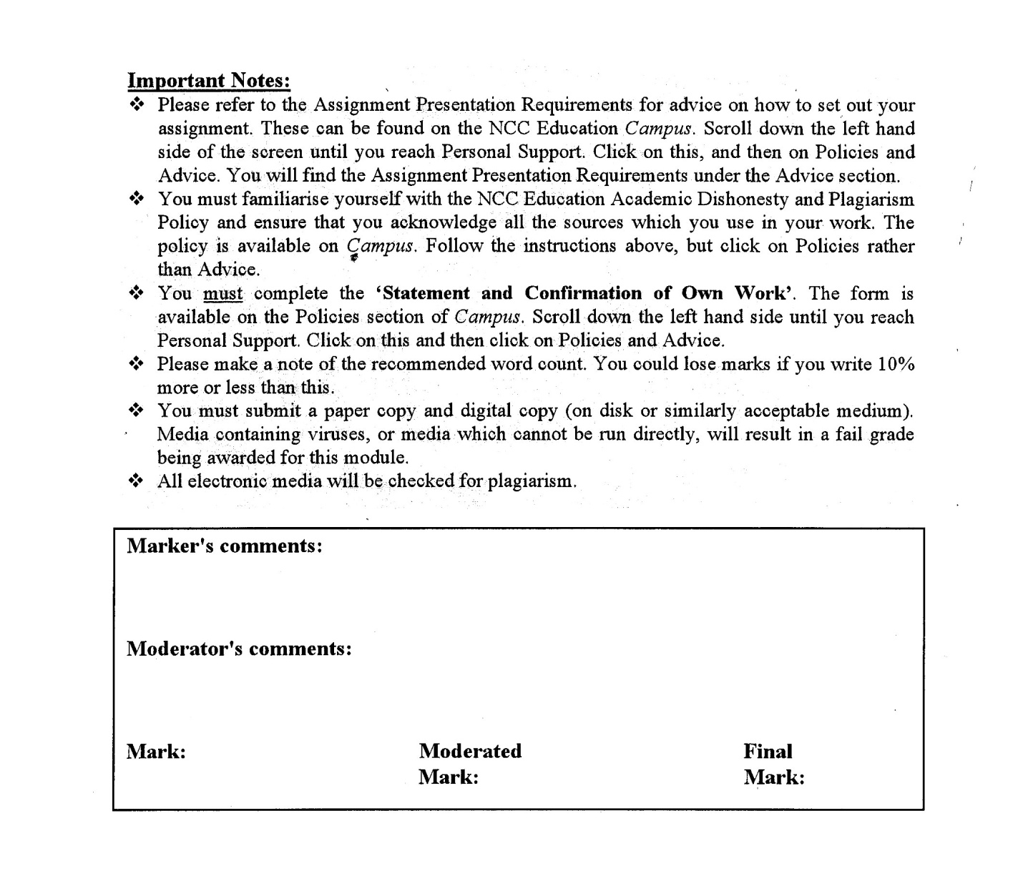



**Statement and Confirmation of Own Work**

**Programme/Qualification name: L4DC**

***All NCC Education assessed assignments submitted by students must have this statement as the cover page or it will not be accepted for marking. Please ensure that this statement is either firmly attached to the cover of the assignment or electronically inserted into the front of the assignment.***

**Student declaration**

**I have read and understood NCC Education’s Policy on Academic Dishonesty and Plagiarism.**

**I can confirm the following details.**

**Student ID/Registration number : P00200770**

**Name : YAN LINN AUNG**

**Centre Name : KMD COMPUTER CENTRE (YANGON)**

**Module Name : COMPUTER SYSTEMS**

**Module Leader : HEIN SITHU NYUNT**

**Number of words : ( ) words**

**I confirm that this is my own work and that I have not plagiarised any part of it. I have also noted the assessment criteria and pass mark for assignments.**

**Due Date :**

**Student Signature :**

**Submission Date :**

Table of Contents

**Important Notes:** 1

❖ You must familiarise yourself with the NCC Education Academic Dishonesty and Plagiarism Policy and ensure that you acknowledge all the sources which you use in your work. The policy is available on *Campus*. Follow the instructions above, but click on Policies rather than Advice. 1

❖ You must submit a paper copy and digital copy (on disk or similarly acceptable medium).Media containing viruses, or media which cannot be run directly, will result in a fail grade being awarded for this module. 1

**Statement and Confirmation of Own Work** 2

**Programme/Qualification name: L4DC** 2

**Student declaration** 2

**Due Date**  **:** 2

**Student Signature**  **:** 2

**Submission Date**  **:** 2

Updating IT Infrastructure 4

Windows Installation 6

TASK 2 7

WINDOWS INSTALLATION 7

a) Installation of Windows 7

1. Identification of key stages in the installation 7

References for Task (1): 10

Candidate Checklist 11

**Task (1)**

# Updating IT Infrastructure

**Task (2)**

# Windows Installation

# TASK 2

# WINDOWS INSTALLATION

## a) Installation of Windows

### 1. Identification of key stages in the installation

We must make sure our machine satisfies the system requirements, obtain the installation media, make a bootable USB or DVD, have a working product key for activation, back up critical files, and, if desired, have an internet connection in order for Windows 10 Pro to install successfully. It is imperative to follow the installation guidelines supplied by Microsoft or the related documentation.

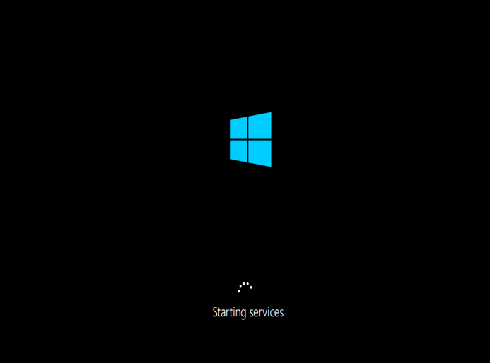

**Task (3)**

**Faulty PCs and Software Maintenance**

# References for Task (1):

# Candidate Checklist

Please use the following checklist to ensure that your work is ready for submission.



Have you read the NCC Education documents 'What is Academic Misconduct? Guidance for Candidates' and 'Avoiding Plagiarism and Collusion: Guidance for Candidates' and ensured that you have acknowledge all the sources that you have used in your work?



Have you completed the 'Statement and Confirmation of Own Work' form and attached it to your assignment? **You must do this**.

Have you ensured that your work has not gone over or under the recommended word count by more than 10%?



Have you ensured that your work does not contain viruses and can be run directly?

